Красноярская олимпиада школьников 2023-2024 учебный год
Школьный этап. Английский язык, 3 класс
LISTENING
Time: 10 minutes
Maximum points – 10

Task 1. Listen and write the correct answer. You will hear the recording twice.
Послушай и запиши или выбери правильный ответ. Ты услышишь запись дважды.

- What is the name of the girl?____________
- How old is she?__________
- Where is she from?
- London | - Oxford | - Cambridge
- What is her mum?
- A teacher | - A doctor | - A manager
- What is her dad?
- A driver | - A doctor | - A reporter
- What is her sister’s name?
- Rosie | - Rose | - Rita
- How old is her sister?_________
- What is her brother’s name?__________
- How old is her brother?_____________
- Toto is their___________.
Transfer your answers to the answer sheet.
Не забудь перенести свои ответы в бланк ответов!

Красноярская олимпиада школьников 2023-2024 учебный год
Школьный этап. Английский язык, 3 класс
READING
Time: 10 minutes
Maximum points – 10
Task 1. Complete the letter. Дополни письмо.

centre noisy hotel big shops

Dear Jenny,
I’m in Oxford. It’s a 1)__________ town. The 2)________ of the town is old and pretty. There are lots of 3) _____________ and there are lots of tourists. Today is Saturday. It isn’t quiet. It’s 4)_____________ . We are in a big 5)___________.
How are you? I’m fine.
Love from
Rebecca

Task 2. Read the letter. Are the sentences true (T) or false (F)? Прочитай письмо. Отметь верные (Т) и неверные (F) предложения.
Dear Rebecca,
My Mum and Dad and I are in Edinburgh. Edinburgh is a big town. The centre is old. There are lots of shops. Today is Sunday and it is quiet. We are in a small hotel.
How are you? We’re fine.
Love from
Jenn

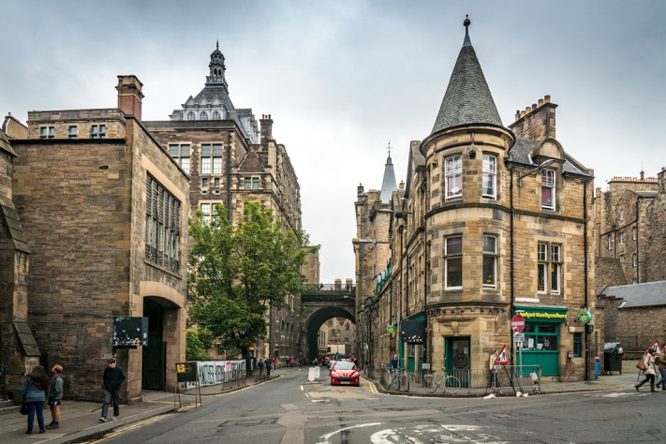

6. Jenny is in Edinburgh. T/F
7. Edinburgh is noisy on Sunday. T/F
8. Edinburgh is a small town. T/F
9. The centre of Edinburgh is old. T/F
10. Jenny is in a small hotel. T/F
Transfer your answers to the answer sheet.
Не забудь перенести свои ответы в бланк ответов!
Красноярская олимпиада школьников 2023-2024 учебный год
Школьный этап. Английский язык, 3 класс
USE OF ENGLISH
Time: 10 minutes
Maximum points – 15
Task 1. Read the sentences and fill in the articles. Прочитай предложения, вставь артикль the там, где это необходимо.
Пример: It’s time to play _-_ football.

1. It’s time to have__________breakfast.
2.It’s time to go to____________school.
3.It’s time to go to________________park.
4.It’s time to go to ________________bed.
5.It’s time to go to ________________zoo.

Task 2. Choose the correct variant. Выбери правильное пропущенное слово. Есть пример.
Butterflies
Butterflies(0) are insects.They (6)……… six legs and (7) be many beautiful colours. There are thousands of different kinds of butterflies and (8)…….. live in many places around the world. Butterflies usually (9)………. plants. Butterflies have four wings.Some of them are big (10)……… some are very small.
0 | - are | - is | - am
6 | - has | - are | - have
7 | - can | - have | - are
8 | - they | - their | - them
9 | - eating | - eat | - eats
10 | - and | - then | - but

Task 3. Make up sentences. One word is odd. Собери предложение, одно слово в каждой строчке лишнее.
Пример: with, computer, friends. plays, morning, his, games, He, - He plays computer games with his friends.

11. We, homework. our, do, always, are,
12.his, drives, often, car. He, on,
13.eat, afternoon, lunch. for, pizza, I,
14. He, forest, bike. his, rides,
15. They, has, read, books. never,

Transfer your answers to the answer sheet.
Не забудь перенести свои ответы в бланк ответов!

Красноярская олимпиада школьников 2023-2024 учебный год
Школьный этап. Английский язык, 3 класс
WRITING
Time: 15 minutes
Maximum points – 10

Read Tom’s letter and answer his questions. Прочитай письмо от твоего нового друга Тома и ответь на его вопросы. Не забудь формат письма! Напиши 40-50 слов.

Dear friend,

My name is Tom. I am from the USA. I live in New York. I am nine years old.
I go to school and I am a very good pupil. My favourite lessons are English and Russian. My hobby is collecting stamps. I have got a great collection of them.
What about you? How old are you? What are your favourite lessons? What is your hobby?

I hope to hear from you soon. Best wishes.
Yours,
Tom

